COMP201 - Assignment 1

Name: Jin, Minhao

University Username: sgmjin2

Student ID: 201447766

Task 1

Use case Diagram:

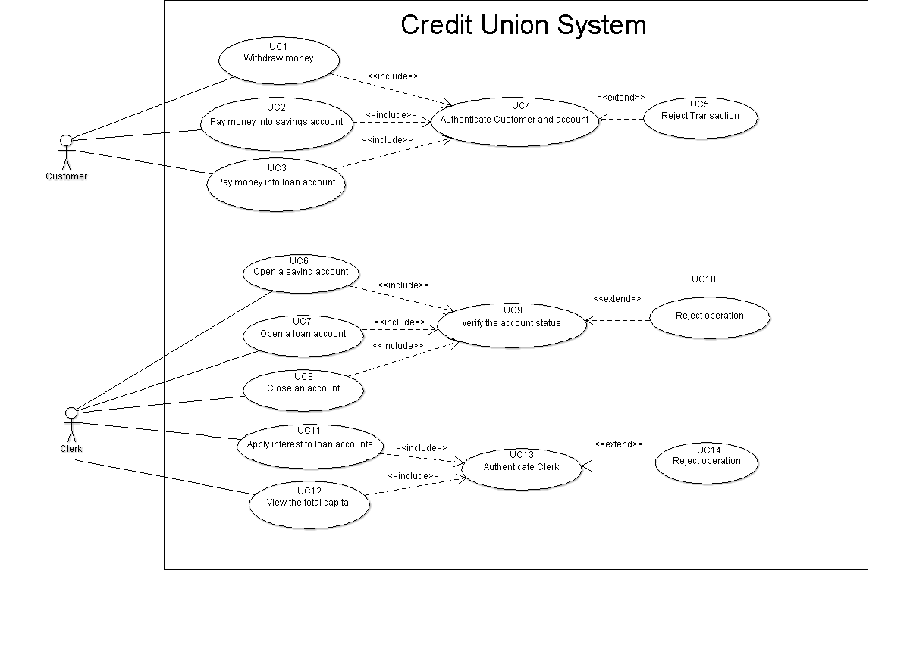

Use case description:

|  |  |
| --- | --- |
| ID | UC1 |
| Name | Withdraw money |
| Description | Credit Union customer withdraw money |
| Pre-condition | Credit Union system in service  Credit Union has sufficient cash in stock |
| Event flow | 1. Include Use case 4 ‘Authenticate customer’ 2. Check balance 3. Choose receipt option 4. Take cash |
| Extension points |  |
| Triggers | Withdraw cash service requested |
| Post-condition | Balance updated  Cash dispensed  Total capital in Credit Union decreased |

|  |  |
| --- | --- |
| ID | UC2 |
| Name | Pay money into saving account |
| Description | Credit Union customer pays money into his/her saving account |
| Pre-condition | Credit Union system in service |
| Event flow | 1. Include Use case 4 ‘Authenticate customer’ 2. Check balance 3. Choose the mode of saving money 4. Save money into the customer’s saving account |
| Extension points |  |
| Triggers | Saving cash service requested |
| Post-condition | Balance updated  Total capital in Credit Union increased |

|  |  |
| --- | --- |
| ID | UC3 |
| Name | Pay money into loan account |
| Description | Credit Union customer pays money into his/her loan account |
| Pre-condition | Credit Union system in service |
| Event flow | 1. Include Use case 4 ‘Authenticate customer’ 2. Check balance 3. Pay money into customer’s loan account |
| Extension points |  |
| Triggers | Paying loan service requested |
| Post-condition | Balance updated  Total capital in Credit Union increased |

|  |  |
| --- | --- |
| ID | UC4 |
| Name | Authenticate customer and account |
| Description | Credit Union customer proves his/ her identity |
| Pre-condition | Credit Union system in service |
| Event flow | 1. If customer and account already authenticated, exit from use case 2. Credit Union customer enters name 3. Check the amount of money customer wants to pay or withdraw is valid |
| Extension points | Use case 5 “reject transaction” |
| Triggers | Authenticated service requested and customer not authenticated |
| Post-condition | Credit Union customer is authenticated if credentials correct |

|  |  |
| --- | --- |
| ID | UC5 |
| Name | Reject transaction |
| Description | Credit Union rejects customers’ transaction |
| Pre-condition | Credit Union customer is not authenticated |
| Event flow | 1. Reject any operation of this customer |
| Extension points |  |
| Triggers | Credit Union customer is not authenticated |
| Post-condition | This customer cannot pay or withdraw money |

|  |  |
| --- | --- |
| ID | UC6 |
| Name | Open a saving account |
| Description | Credit Union clerk opens a saving account for the customer |
| Pre-condition | Credit Union system in service  Credit Union clerk is free |
| Event flow | 1. Include use case 9 “verify account status” 2. Credit Union clerk enters customer’s name 3. Credit Union clerk takes customer’s money 4. Credit Union clerk opens a new saving account for the customer and saves corresponding money the customer requested |
| Extension points |  |
| Triggers | Open saving account service requested |
| Post-condition | Balance of this new saving account updated  Total capital in Credit Union increased |

|  |  |
| --- | --- |
| ID | UC7 |
| Name | Open a loan account |
| Description | Credit Union clerk opens a loan account for the customer |
| Pre-condition | Credit Union system in service  Credit Union clerk is free |
| Event flow | 1. Include use case 9 “verify account status” 2. Credit Union clerk enters customer’s name 3. Credit Union clerk opens a new loan account for the customer and takes out corresponding money the customer requested 4. Credit Union clerk gives cash to the customer |
| Extension points |  |
| Triggers | Open loan account service requested |
| Post-condition | Balance of this new saving account updated  Total capital in Credit Union increased |

|  |  |
| --- | --- |
| ID | UC8 |
| Name | Close an account |
| Description | Credit Union clerk close an account for the customer |
| Pre-condition | Credit Union system in service  Credit Union clerk is free |
| Event flow | 1. Include use case 9 “verify account status” 2. Close the account that customer requested |
| Extension points |  |
| Triggers | Close account service requested |
| Post-condition | Remove the information of this account out of the Credit Union system  Total capital in Credit Union updated |

|  |  |
| --- | --- |
| ID | UC9 |
| Name | verify the account status |
| Description | Credit Union clerk check the account status |
| Pre-condition | Credit Union system in service  The clerk opens or closes an account |
| Event flow | If clerk opens an account   1. Check the amount of money customer wants to loan is valid 2. Check the amount of money customer wants to save is valid   If clerk closes an account   1. Check the balance of this account |
| Extension points | Use case 10 “reject operation” |
| Triggers | The clerk is ready to open or close an account |
| Post-condition | Opening or closing an account is allowed if the operation is valid |

|  |  |
| --- | --- |
| ID | UC10 |
| Name | Reject operation |
| Description | Credit Union clerk rejects to open or close an account |
| Pre-condition | Credit Union system in service  The account status after operation is invalid |
| Event flow | 1. Open or close an account is rejected by the clerk |
| Extension points |  |
| Triggers | The account status after operation is invalid |
| Post-condition | Operation denied |

|  |  |
| --- | --- |
| ID | UC11 |
| Name | Apply interest to loan accounts |
| Description | Credit Union clerk applies interest to loan accounts weekly |
| Pre-condition | Credit Union system in service |
| Event flow | 1. Include use case 13 “Authenticate clerk” 2. Credit Union clerk applies interest 3. Update all the loan balance in the Credit Union system |
| Extension points |  |
| Triggers | Credit Union clerk is ready to apply interest to loan accounts |
| Post-condition | all the loan balance in the Credit Union system updated |

|  |  |
| --- | --- |
| ID | UC12 |
| Name | View the total capital |
| Description | Credit Union clerk views the total capital of Credit Union |
| Pre-condition | Credit Union system in service |
| Event flow | 1. Include use case 13 “Authenticate clerk” 2. Credit Union clerk views the total capital |
| Extension points |  |
| Triggers | Credit Union clerk is ready to view the total capital of Credit Union |
| Post-condition | Credit Union clerk get the value of total capital |

|  |  |
| --- | --- |
| ID | UC13 |
| Name | Authenticate Clerk |
| Description | Credit Union clerk proves his/ her identity |
| Pre-condition | Credit Union system in service |
| Event flow | 1. If the clerk already authenticated, exit from uses case 2. Check whether this clerk works for Credit Union |
| Extension points | Use case 14 “reject transaction” |
| Triggers | Authenticated service requested and clerk not authenticated |
| Post-condition | Credit Union clerk is authenticated if credentials correct |

|  |  |
| --- | --- |
| ID | UC14 |
| Name | Reject operation |
| Description | Credit Union rejects the operation |
| Pre-condition | Credit Union system in service |
| Event flow | Credit Union clerk is not authenticated |
| Extension points | Reject any operation of this clerk |
| Triggers | Credit Union clerk is not authenticated |
| Post-condition | This clerk cannot pay or withdraw money |

Task 2

5 functional requirements

1. The system shall be able to update all the information of clerks, customers and customers’ accounts.
2. The system shall be able to judge whether the clerk can open or close an account for the customer.
3. An authenticated customer shall be able to withdraw from and pay money into his/ her account.
4. An authenticated clerk shall be able to view the total capital and apply interest to all the loan account in the system weekly.
5. The system shall be able to deny the operation if the user is not authenticated.

Task 3

5 non-functional requirements

1. The System should have a maximum response time of 5 seconds when processing transactions.

To verify that the system can response within 5 seconds when processing transactions, a monitoring system can be attached to this product, which document all response times when transaction happens. This monitoring system is also able to alert software engineers when response time of the system is greater than the threshold.

1. The system is to comply with the regulations set out in GDPR.

A legal domain consultant or expert will be hired to check whether the system meets all the expected standards.

1. The system should have a user-friendly interface.

An investigation can be created for some system users, asking their opinion of the user interface. If the consensus is that it is user-friendly, then this requirement has been met. Otherwise, the interface should be improved to satisfy this requirement, such as using graphics and adding more instructions for the users.

1. The system should be portable and be able to run on a single laptop computer.

To verify this requirement, we should check that the size of system itself is available for a laptop computer at first. Then, it should be also measured that how much memory will be occupied when the system is running. If both sub-requirements are met, the system can be verified as portable.

1. The system should be robust with a low probability of data corruption on failure.

To verify this requirement, some extreme situation can be tested on the system such as sudden electricity failure and many simultaneous operations. If all the data can be kept safely, this requirement is verified.

Task 5

UML Sequence diagram: 